Contents

Non-Player Characters 2

Buppido 2

On the subject of 2

Mannerisms 2

Prince Derendil 3

Eldeth Feldrun 3

Jimjar 3

Ront 3

Sarith Kzekarit 3

Shuushar the Awakened 3

Stool 3

Topsy and Turvy 3

# Non-Player Characters

## Buppido

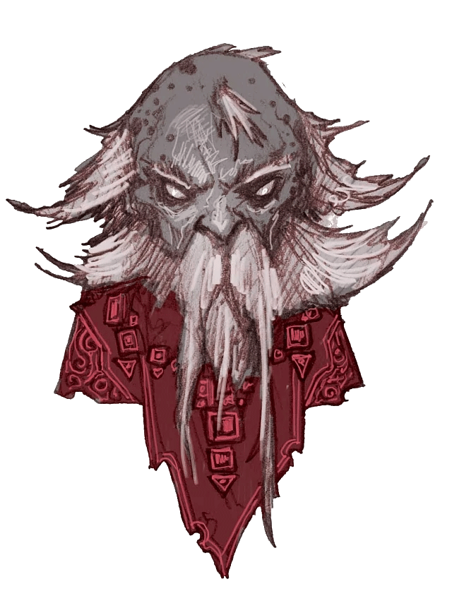*You approach what appears to be a small male dwarf with blue-grey skin and straight white hair wreathing around a liver-spotted bald head. His pale white eyes lack both irises and pupils. A white beard bushes off his checks and long whiskers droop down obscuring his mouth.*

*As you approach, a disarming smile flashes across his face and he start making his way toward you as if to close the gap together.*

*His voice is oddly deep yet gregarious as he greets you.*

*“I’m Buppido, been a prisoner here longer than anyone. You must be confused. Is there anything I can explain?”*

### On the subject of

#### … dwarves

*“Yessss… interesting what’s-her-name over there …”*

*He gestures toward a redheaded traditional dwarven woman (Eldeth Feldrun).*

*“talked to me about dwarfs when she got her. Don’t really know what she was talking about though. I’m a Derro created by Diirinka hisself. Soooo…”*

#### … breaking out

*“Yes! When it is time I am with you friends. Ol’ Buppido is with you!”*

### Buppido is…

#### … insane

*Buppido just stares off into the middle distance for a long few seconds. As he does, a weird unsettling intensity grows in his eyes. Suddenly he snaps out of it and catches himself. Blinking his smile returns… “What was I saying?”* (alternatively) *“Can you repeat that?”*

#### … believes he is a god

Buppido calls any setbacks he encounters “*Just part of our divine plan.”*

#### … is completely fearless

*As you and your fellow prisoners slave away swinging pickaxes at stone, Buppido strides over to you. Sharp shrapnel of flecked stone fly by him and pickaxes nearly take his head off as he walks. By the time he reaches you about half a dozen small cuts bleed from his arms. He notices none of this.*

### Insights

#### DC 10:

*As Buppido speaks his generally pleasant façade seems to conceal something…*

#### DC 15:

*…something dark. There is a strange level of ego behind his words…*

#### DC 20:

*…you realize that this tiny man terrifies you in some strange way.*

### Potential Side Plots

#### Ritualistic knolling

*Each morning small groups of debris seem to be positioned in a clearly intentional way… almost like stones stacked to mark a hiking trail. There’s no clear meaning behind it and no one seems to know who did it.*

## Prince Derendil

## Eldeth Feldrun

## Jimjar

## Ront

## Sarith Kzekarit

## Shuushar the Awakened

## Stool

## Topsy and Turvy